FOR IMMEDIATE RELEASE
Local Press Contact:
Brianna Poplaskie
BRAVE Public Relations
404.233.3993
bpoplaskie@emailbrave.com

Click here to download tour cast headshots.
Click here to download Broadway production photos & B-Roll

“ROOF-RAISING! IT HITS THE RAFTERS.
THIS IS TINA AS WE KNOW AND ADORE HER.” – Variety

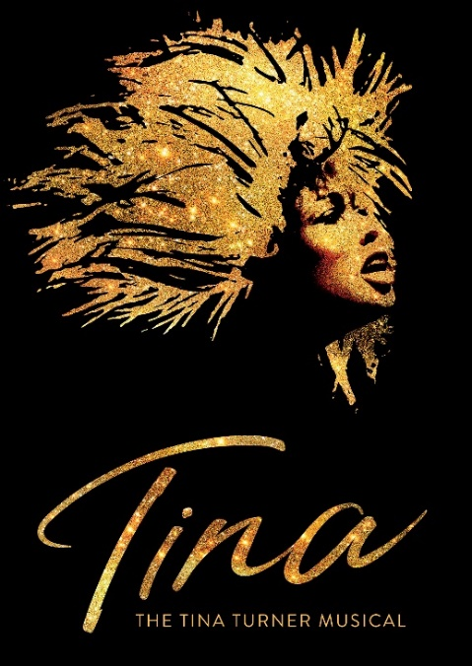

TICKETS WILL GO ON SALE
DEC. 2, 2022

PLAYS ATLANTA’S FOX THEATRE
FEB. 21 TO FEB. 26, 2023

“PREPARE TO BE ECSTATICALLY BLOWN AWAY!”– The Daily Beast

“I’VE RARELY HEARD AN AUDIENCE WITH THIS MIGHTY A ROAR.” – NY Times

“MIND-BLOWING AND LIFE CHANGING.
A story that needs to be shared, especially today." – ABC News

ATLANTA, Ga. (Nov. 29, 2022)- Regions Bank Broadway in Atlanta is delighted to announce that tickets for TINA – THE TINA TURNER MUSICAL will go on sale on Dec. 2 for eight performances from Feb. 21 to Feb. 26, 2023.

The cast is led by Naomi Rodgers (Frozen) and Zurin Villanueva (The Lion King, Mean Girls, Shuffle Along, The Book of Mormon) who will evenly share the role of Tina Turner, each playing four (of eight) performances a week. Also starring are Garrett Turner as Ike Turner, Roz White as Zelma Bullock, Ann Nesby as Gran Georgeanna and Lael Van Keuren as Rhonda.
The ensemble includes Daelyanna Kelly Benson, Antonio Beverly, Taylor A. Blackman, Aliyah Caldwell, Lillian Charles, Max Falls, Zachary Freier-Harrison, Reyna Guerra, Gordia Hayes, Andre Hinds, Takia Hopson, Ayvah Johnson, Geoffrey Kidwell, Parris Mone’t Lewis, Nia Nelson-Williams, Gracie Phillips, Nicole Powell, Terance Reddick, Shari Washington Rhone, Jacob Roberts-Miller, Aniya Simone, Chris Stevens, Jeff Sullivan and Carlton Terrence Taylor.
“It has been years since I toured the US and I am very excited that my own musical can now bring my music and story to my fans in their home cities across America. It’s a homecoming and that is very special to me,” said Tina Turner.

“We are delighted to begin this next chapter for TINA – THE TINA TURNER MUSICAL. The North American tour will see the show enjoy its sixth production around the world since opening in the West End in 2018, which is testimony to Tina’s extraordinary legacy. This tour clearly has special resonance for Tina herself, and now more than ever we can’t wait to uplift audiences across America with her joyful and triumphant story," the producers, Tali Pelman from Stage Entertainment and Jimmy Nederlander said. “We can’t wait to introduce America to the two megawatt superstars—Naomi Rodgers and Zurin Villanueva — who will share the role of Tina, Garrett Turner in the role of Ike and the incredibly talented company who are hitting the on the road on tour!"

Produced by Stage Entertainment, James L. Nederlander and Tali Pelman, in association with Tina Turner, TINA – THE TINA TURNER MUSICAL was written by Tony Award nominee and Pulitzer Prize winner Katori Hall with Frank Ketelaar and Kees Prins.

TINA – THE TINA TURNER MUSICAL is directed by Tony Award nominee Phyllida Lloyd with choreography by Tony Award nominee Anthony van Laast, set and costume designs by Tony Award nominee Mark Thompson, musical Music Supervision, Arrangements & Incidental Music by Nicholas Skilbeck, lighting by Tony Award nominee Bruno Poet, sound by Tony Award nominee Nevin Steinberg, projection design by Tony Award nominee Jeff Sugg, orchestrations by Tony Award nominee Ethan Popp, wigs, hair and makeup design by Drama Desk Award winner Campbell Young Associates, and casting by The Telsey Office.
An uplifting comeback story like no other, TINA – The Tina Turner Musical is the inspiring journey of a woman who broke barriers and became the Queen of Rock n’ Roll.

One of the world’s best-selling artists of all time, Tina Turner has won 12 Grammy Awards and her live shows have been seen by millions, with more concert tickets sold than any other solo performer in music history.

This new musical based on the life of legendary artist Tina Turner and presented in association with Tina Turner herself, received its world premiere in April 2018 in London, where it opened to five-star reviews and has broken box office records at the Aldwych Theatre. In March 2019, the German production opened at Stage Operettenhaus in Hamburg, and the Dutch production opened at the Beatrix Theater, Utrecht, in February 2020. A third European production opened in Fall 2021 at the Teatro
Coliseum in Madrid, Spain.

TINA – THE TINA TURNER MUSICAL originally opened on Broadway on November 7, 2019, was nominated for 12 Tony Awards including Best Musical. The production reopened at Broadway’s Lunt-Fontanne Theatre on October 8, 2021, following the 18-month industry wide shut down due to the COVID-19 pandemic. The Broadway production ended performances Sunday, August 14.

Produced by Stage Entertainment and Ghostlight Records and featuring the original London cast, Tina – The Tina Turner Musical: Original Cast Recording is available worldwide on CD, both online and in stores. The CD features a 20-page booklet, which includes liner notes, synopsis, and production and studio photography. The album was recorded in February 2019 at Angel Studios and RAK Studios, produced by the show’s Music Supervisor Nicholas Skilbeck and Kurt Deutsch, and co-produced by Tom Kelly. To download or stream the album, or order the CD, please visit http://www.ghostlightrecords.lnk.to/riverdeep-tinaturnermusical.

When she was inducted into the Rock And Roll Hall of Fame in October, 2021, Tina Turner became one of only three women in the institution’s history to be inducted twice (she was initially inducted in 1991, alongside Ike Turner).

The Emmy-nominated feature documentary TINA is now available to stream on HBO Max. A revealing and intimate look at the life and career of musical icon Tina Turner, TINA charts her improbable rise to early fame, her personal and professional struggles throughout her life and her even more improbable resurgence as a global phenomenon in the 1980s. The feature documentary is from Academy Award-winning directors Dan Lindsay, T.J. Martin and Lightbox, the production company founded by Academy Award-winning producer Simon Chinn and Emmy-winning producer Jonathan Chinn, together with Emmy-nominated producer Diane Becker.

PERFORMANCE SCHEDULE

The performance schedule is as follows:

Tuesday – Thursday 7:30 p.m.
Friday 8 p.m.
Saturday 2 p.m., 8 p.m.
Sunday 1 p.m., 6:30 p.m.

TICKET INFORMATION
Individual tickets for TINA – THE TINA TURNER MUSICAL will go on sale Dec. 2. Tickets will start at $39 with a select number of premium tickets available. Tickets will be available at the Fox Theatre box office at 660 Peachtree Street NE, Atlanta, Georgia 30308, by visiting foxtheatre.org/tina-turner-musical or by calling (855)-285-8499. Group orders of 10 or more may be placed by calling the Fox Theatre at (855)-285-8499.

Follow @TinaBroadway on Twitter, Instagram, and Facebook

# # #

